MEDICAL INVENTORY MANAGEMENT

**COLLEGE NAME:**  Shree Venkateshwara arts and science college

**COLLEGE CODE:** burbd

**TEAM ID:** NM2025TMID20876

**TEAM MEMBERS:**

**Team LeaderName:** J. Pavithra

**Email:** [pavithrajayaraman075@gmail.com](mailto:pavithrajayaraman075@gmail.com)

**Team Member1:** K.D. Giriprasath

**Email:** [giriprasathcyber28@gmail.com](mailto:giriprasathcyber28@gmail.com)

**Team Member2:** R. ruban

**Email:** [ruban4542x@gmail.com](mailto:ruban4542x@gmail.com)

**Team Member3:** R. Jeevanantham

**Email:** [rjeevajs123@gmail.com](mailto:rjeevajs123@gmail.com)

**Team Member4:**  Karmugil

**Email:** [karmugilgcyber2023@gmail.com](mailto:karmugilgcyber2023@gmail.com)

**1.INTRODUCTION:**

* 1. **Project Overview**

Effective inventory management is critical in healthcare settings to ensure the availability of essential medical supplies, equipment and pharmaceuticals. Medical inventory management involves tracking , storing and managing these resources to meet patient needs while minimizing waste, reducing costs and maintaining regulatory compliance.

* 1. **Purpose**

The primary purpose of Medical inventory management is to ensure the efficient and effective management of medical supplies, equipment and pharmaceuticals in healthcare settings.

DEVELOPMENT PHASE:

* Creating developer account.



* Creating a product object.

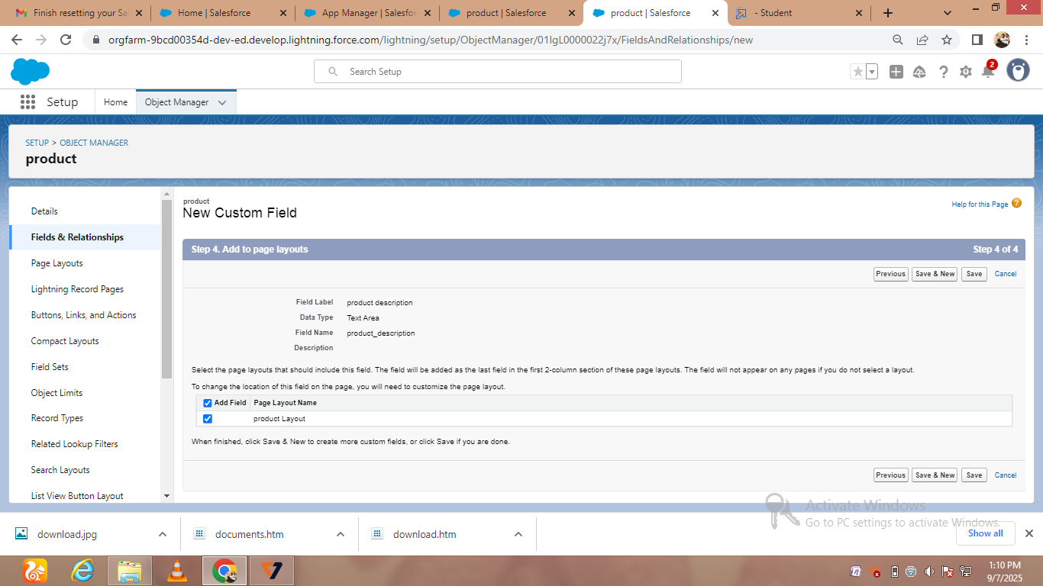

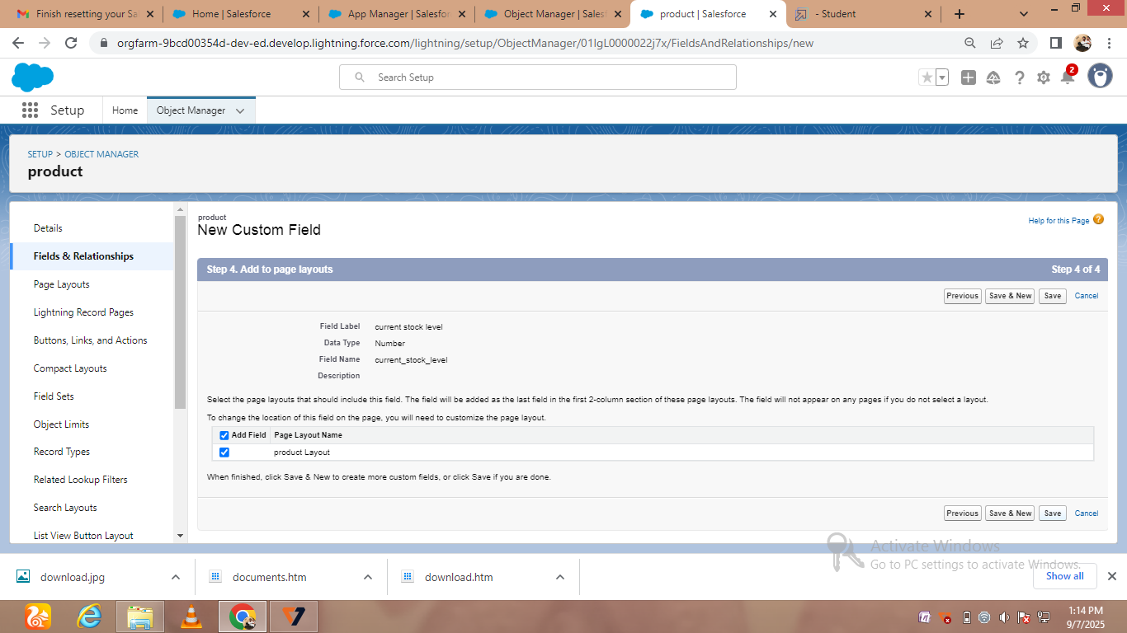

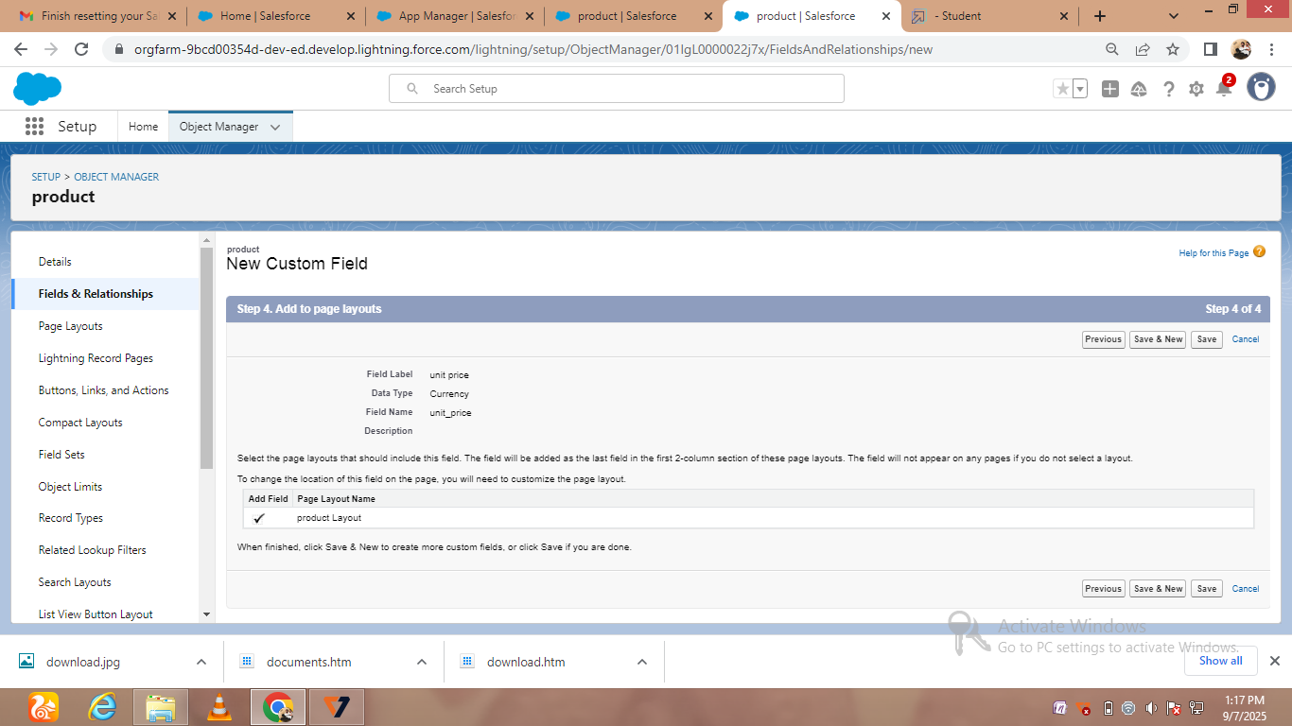

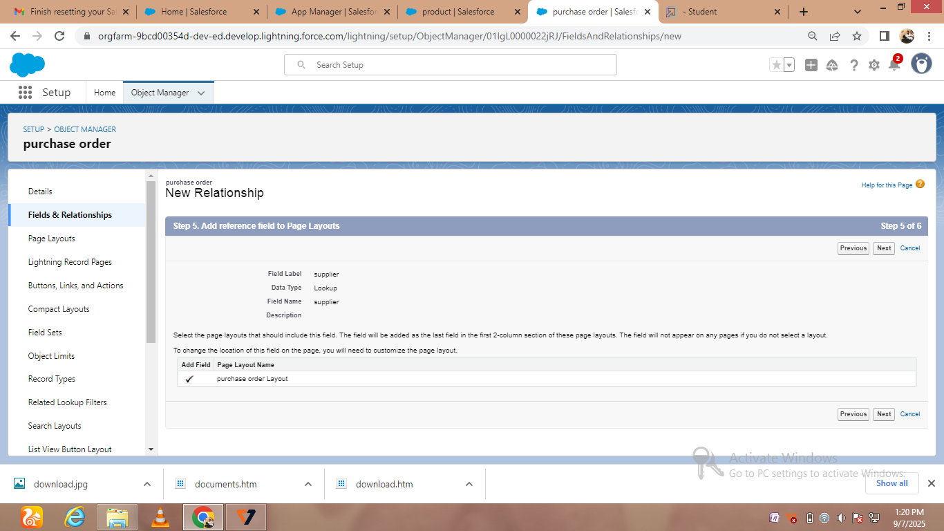

* Creating new Custom field id

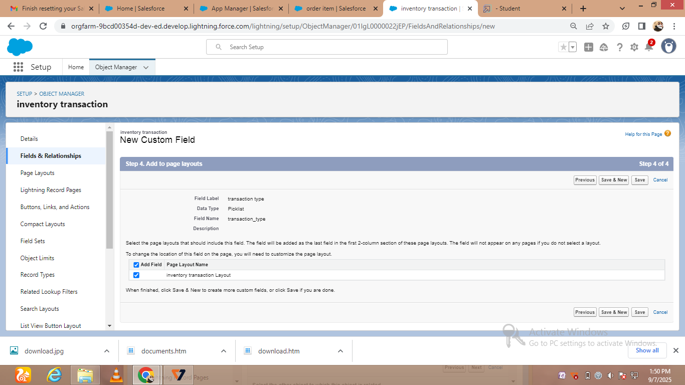

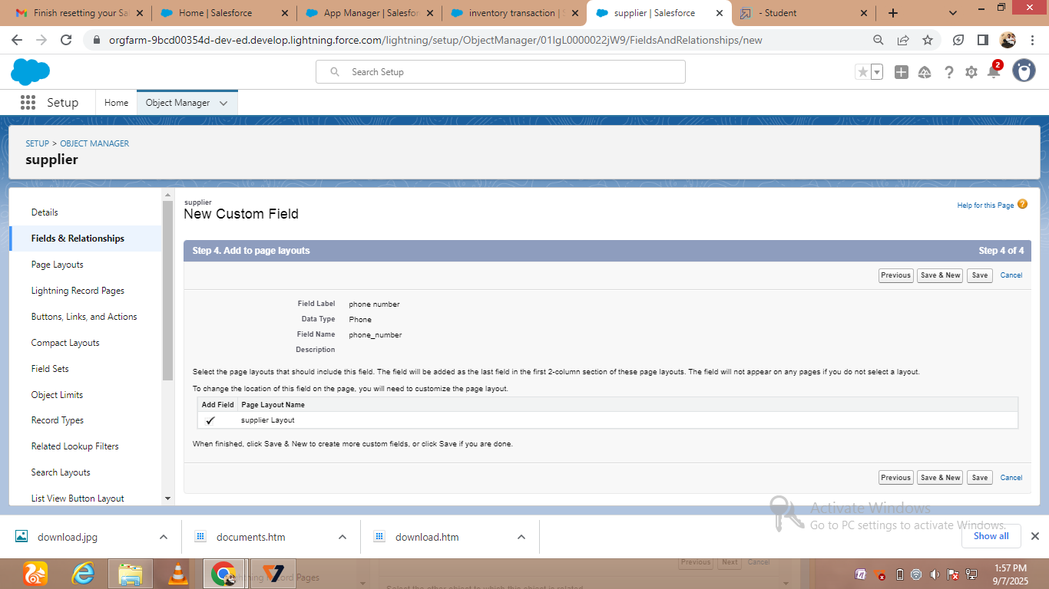

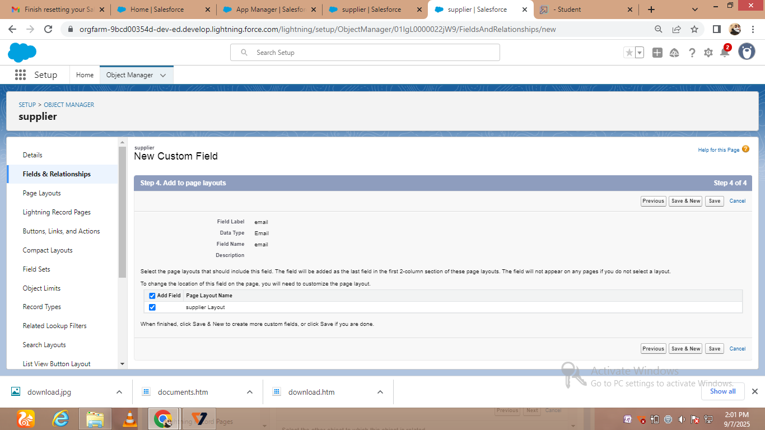

* Creating a customer product

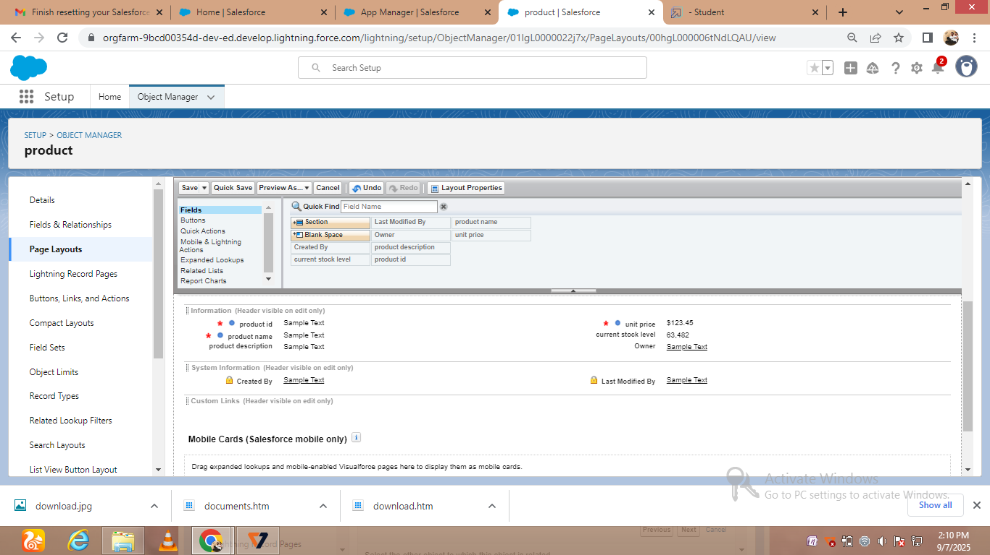

# C:\Users\THIRU\Pictures\Screenshots\Screenshot (26).png

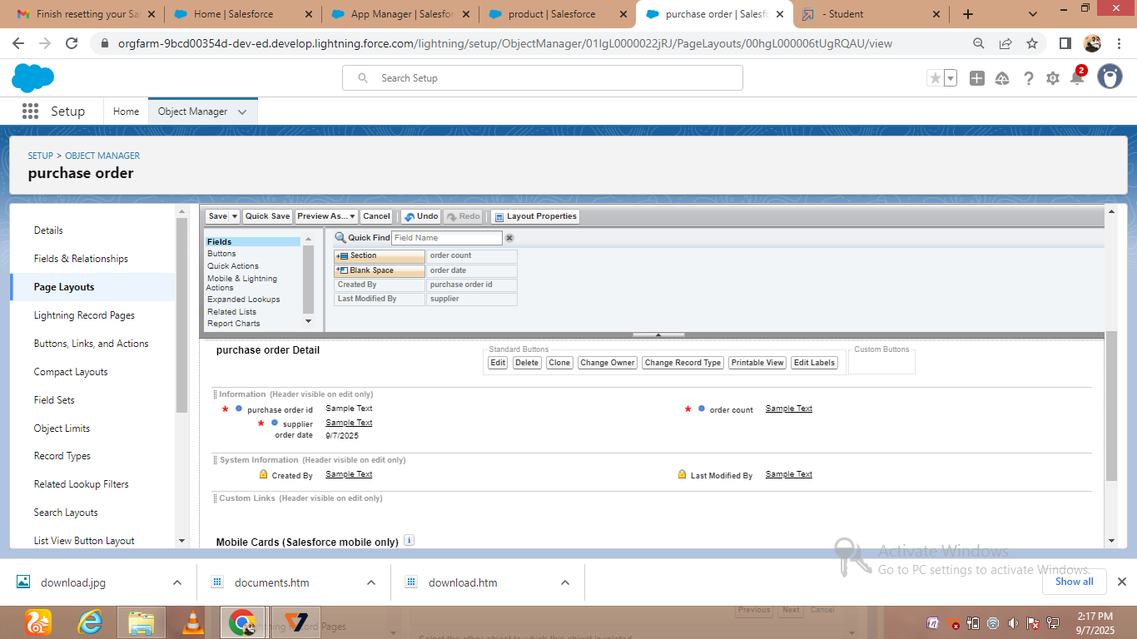

* Creating order item and transaction

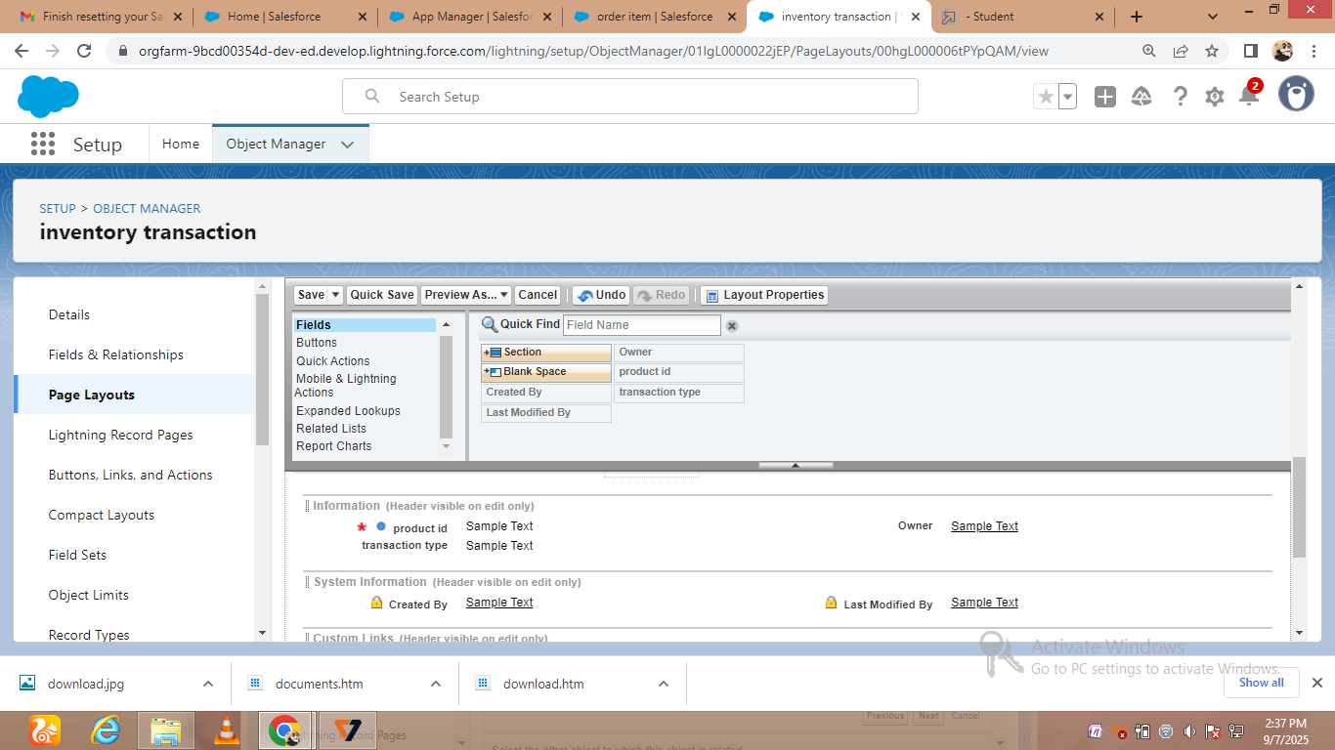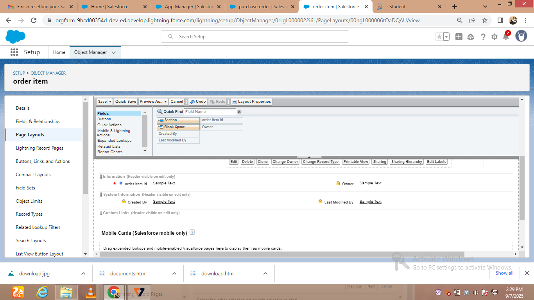



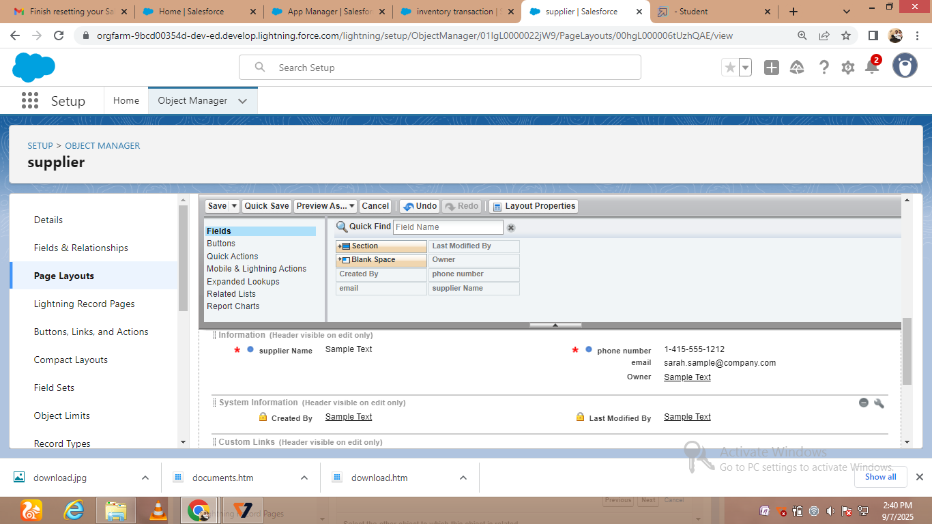

* Creating compact layouts

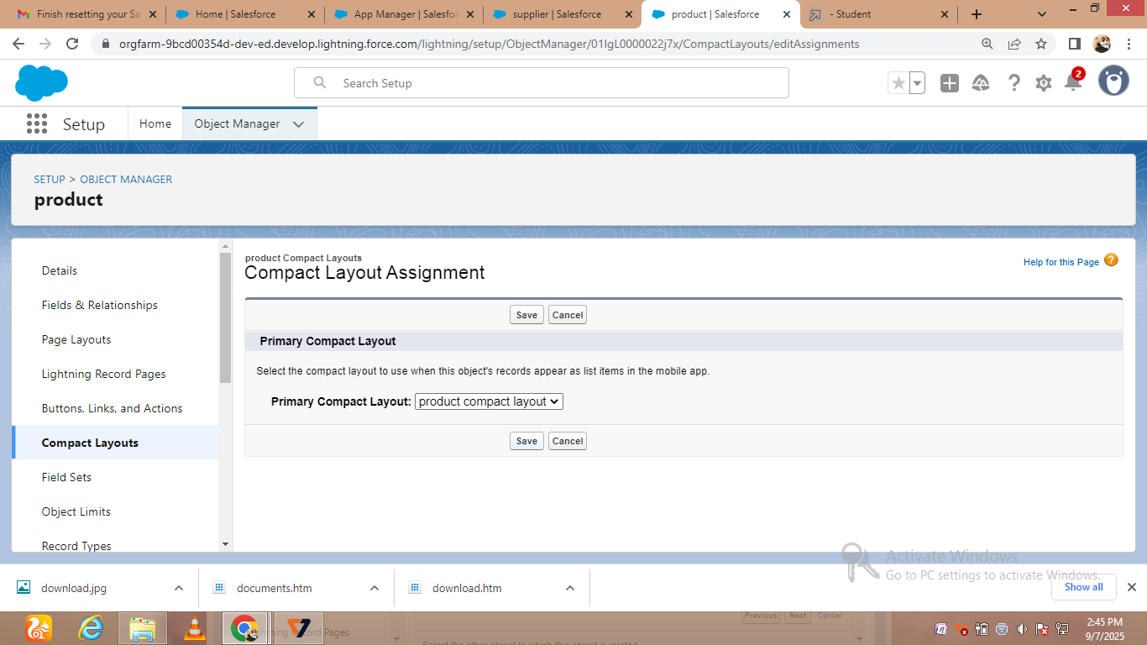 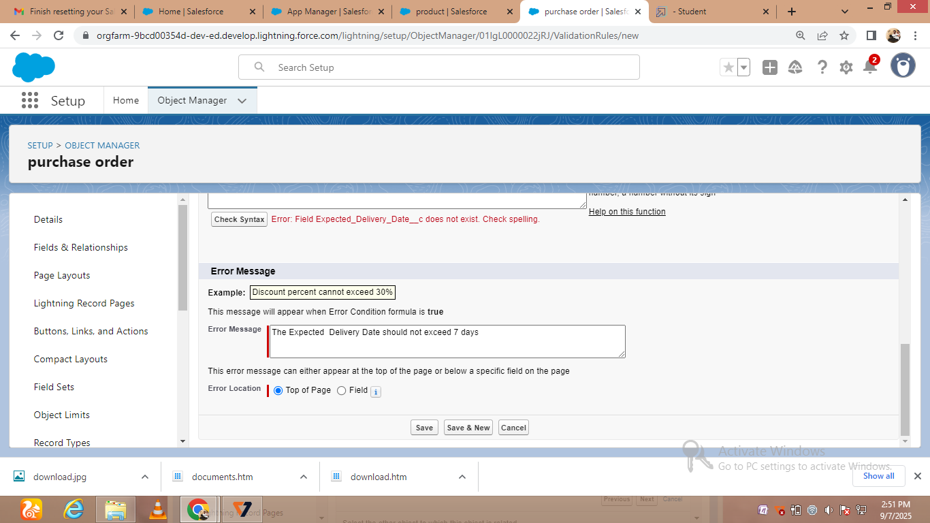

* Creating purchase order validation rule

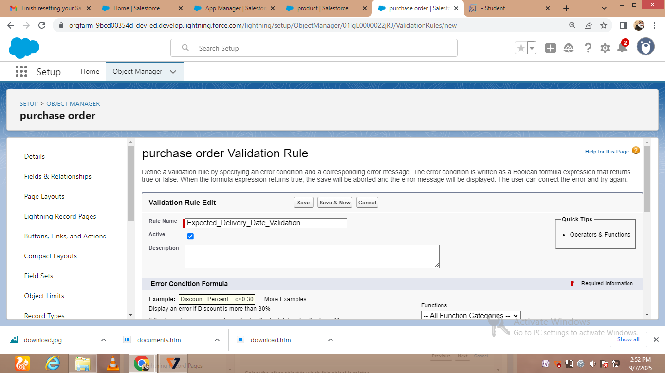

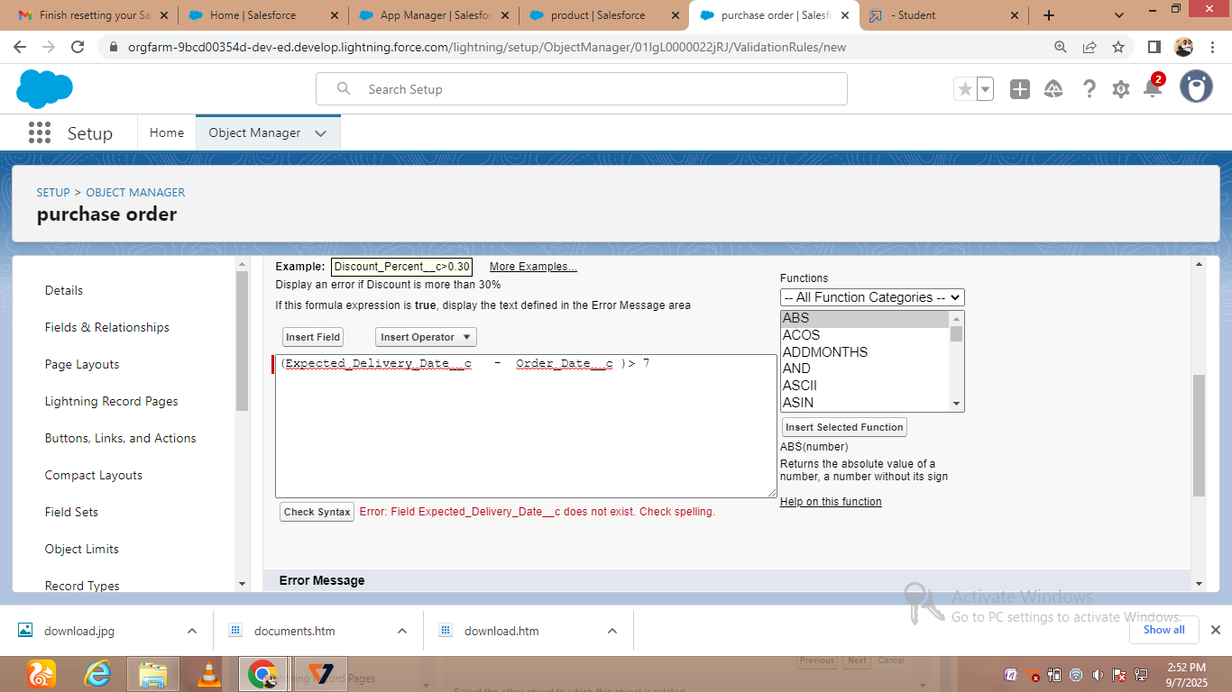



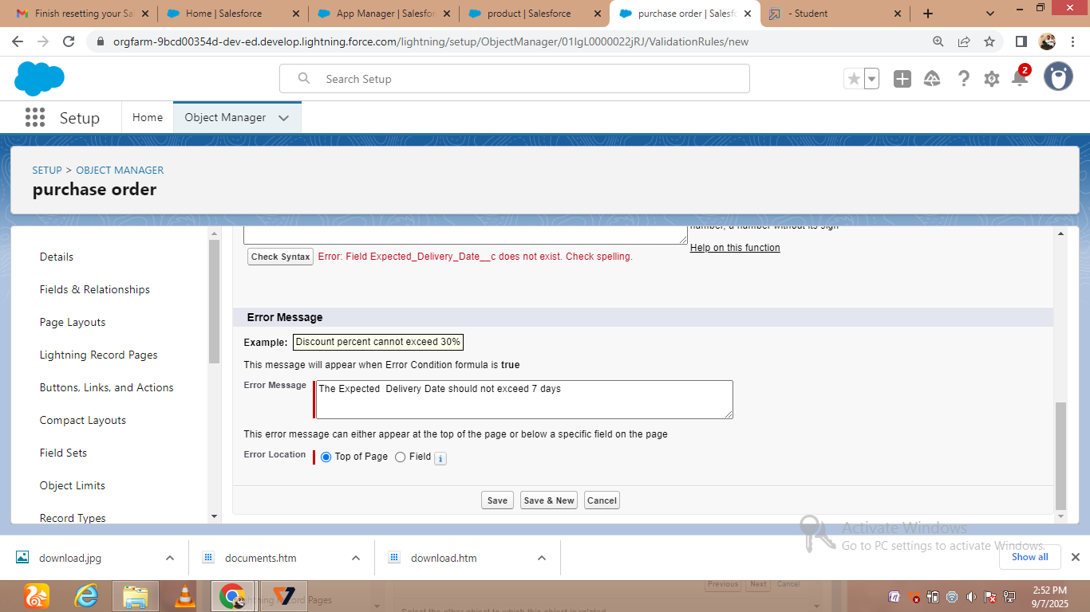

* Creating customer profiles

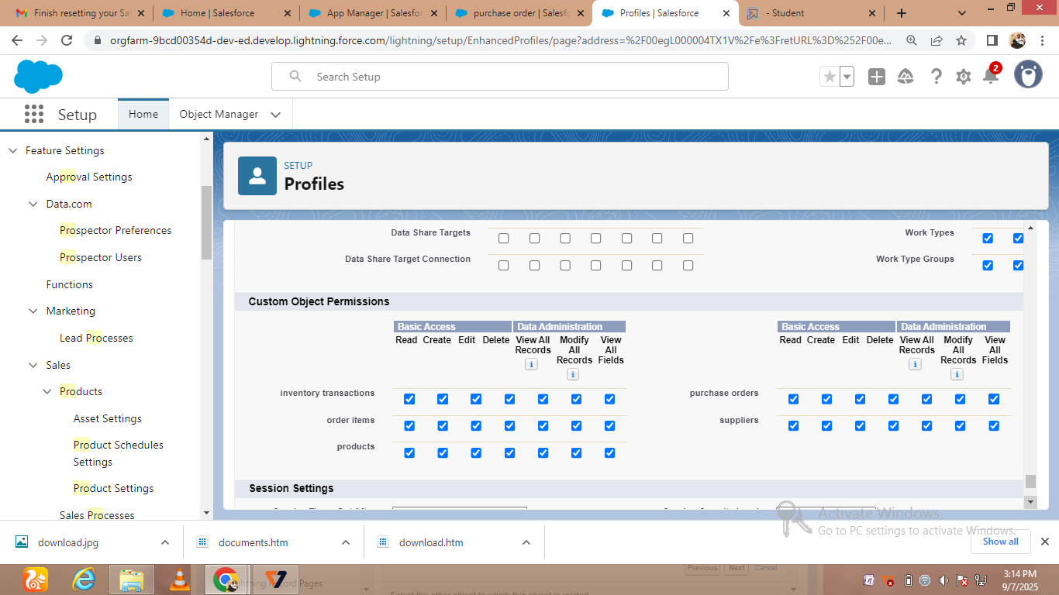

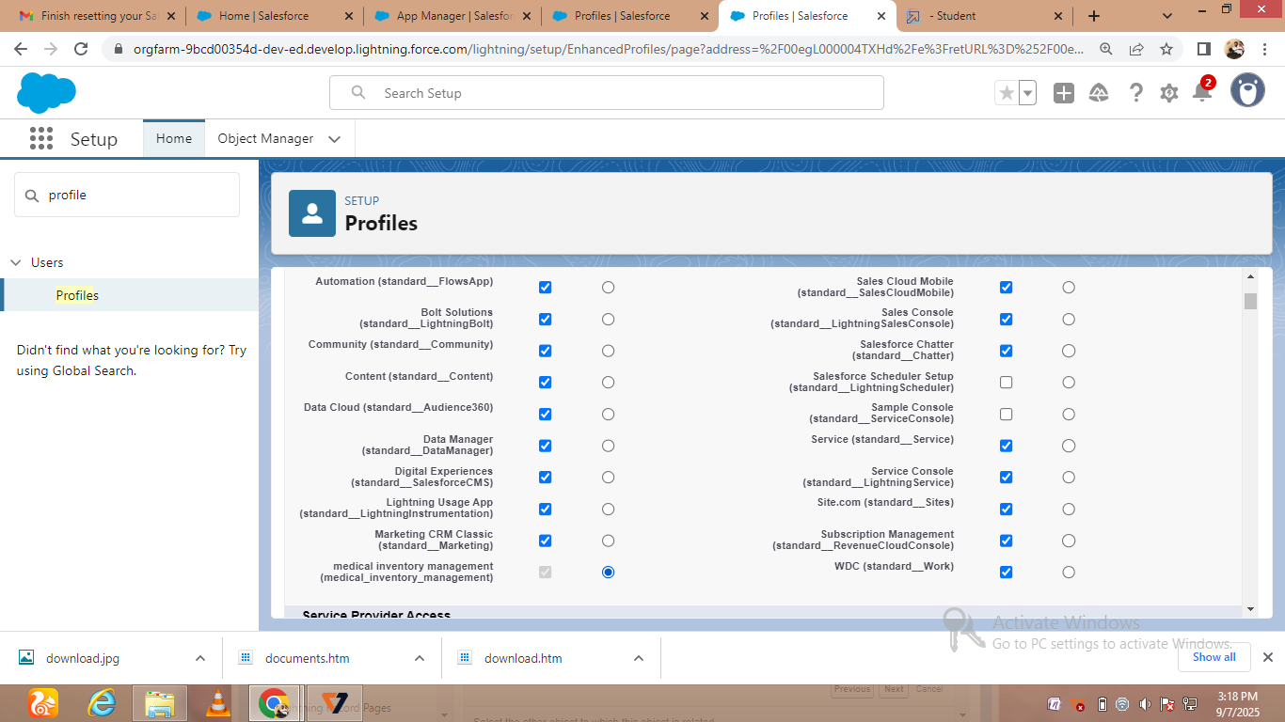

* Creating customer reports

